INVESTMENTS AND INNOVATIONS

Investments

The investment program of IDGC of Centre for 2010 was planned to disburse the capital investments in the amount of 11,82 billion roubles. Actually, for the accounting period 12,23 billion roubles were disbursed or 103 % from the plan.
For 2010 on modernisation and reconstruction of facilities of IDGC of Centre 6,64 billion roubles of capital investments against the plan of 6,2 billion roubles, or 107 % were disbursed. 5,59 billion roubles at the year plan of 5,62 billion roubles, or 99,4 % were disbursed on new construction and expansion in the accounting period. Fixed assets in the amount of 10 billion roubles, or 97 % from the plan, 4 155 km of electric power lines, or 142 % from the plan, transformer capacity of 1050 MVA, or 111 % from the plan were commissioned.

Actual volumes of investments into 2006-2010
Period | Disbursement, excluding VAT | Fixed Assets disbursement, excluding VAT |  | Financing, excluding VAT | Capacity installed |  | Power increase
Period | Billion rbl. | Billion rbl. | Billion rbl. |  | Km | MVA | Km | MVA
2006 | 4,508 | 4,368 | 5,305 |  | 1 676 | 398 | 673 | 136
2007 | 7,839 | 6,371 | 9,250 |  | 3 428 | 698 | 1 945 | 418
2008 | 9,071 | 7,730 | 10,252 |  | 3 263 | 660 | 1 886 | 489
2009 | 6,529 | 7,687 | 6,440 |  | 2 414 | 877 | 1 449 | 685
2010 | 12,230 | 10,008 | 12,503 |  | 4 155 | 1050 | 2777 | 770

Data about actual volume of investments for 2006-2010 with the breakdown by divisions is given in Appendix 5.

During 2010 within the activities of modernisation and reconstruction (retooling and modernization) 1537 km of 0,4-110 kV power lines were reconstructed and 480 MVA transformer capacity was commissioned, within the new construction, expansion and taking onto the books 2618 km of 0,4-110 kV electric power lines and 570 MVA was commissioned. At the end of 2010 the length of electric power lines of the Company amounted to 374 thousand km. Capacity of 35-110kV substations reached 31404 MVA, of 6-10/0,4kV - 15192 MVA.

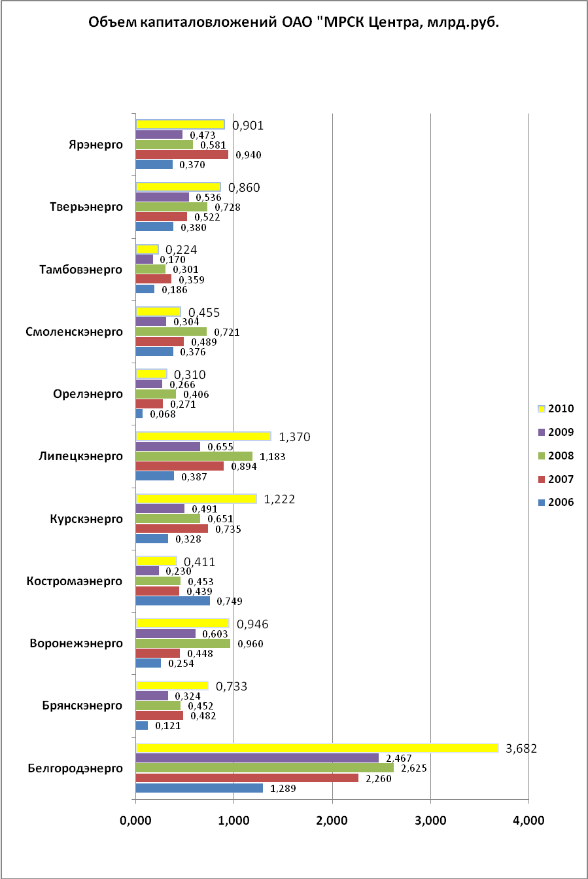

The planned values following the results of work for 2010 were executed for all indicators. The plan overfulfillment on disbursement of capital investments within the Investment program is due to performance of works on technological connection of consumers which were not planned in survey and design activities for 2010.

Area and structure of capital investments, million rbl.
IDGC of Centre, JSC | 2006 | 2007 | 2008 | 2009 | 2010
Structure of investment activity – in total | 4504 | 7839 | 9071 | 6 529 | 12 230
Electric grid facilities, including | 3 579 | 6 125 | 7 596 | 5473 | 9 045
Automation, communication | 210 | 525 | 699 | 406 | 400
Metering and electric power control devices, including | 230 | 208 | 163 | 242 | 497
AMI for the wholesale market as a part of the investment program | 187 | 181 | 84 | 64 | 93
AMI for the retail market and other means of the account and electric power control | 43 | 27 | 79 | 178 | 404
EAD in progress for the next years | 28 | 210 | 203 | 94 | 195
Other industrial and commercial facilities | 275 | 439 | 497 | 117 | 212
Equipment, not included into cost calculation of new construction | 178 | 279 | 292 | 224 | 623
Non production facilities | 1 | 0 | 1 | 0 | 0
Capital investments in intangible assets | 27 | 13 | 0 | 0 | 0
Long-term financial investments |  |  |  |  | 1 100
Acquisition of fixed assets | 187 | 565 | 320 | 379 | 559
Areas of investment activity – in total | 4504 | 7839 | 9071 | 6 529 | 12 230
Technical reequipment and reconstruction | 2133 | 4081 | 5596 | 3 392 | 6 637
including electric grid facilities | 1 695 | 3 497 | 4 761 | 2957 | 5 596
New construction and expansion of existing facilities | 2184 | 3193 | 3155 | 2758 | 5 593
including electric grid facilities | 1 884 | 2 628 | 2 835 | 2516 | 3 449
Acquisition of fixed assets | 187 | 565 | 320 | 379 | 559
For reference only:
Capital investments disbursement for new connections of customers | 677 | 2 446 | 3 486 | 2 188 | 3 832

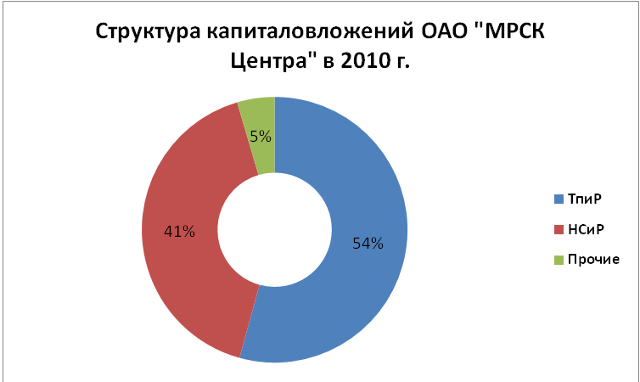
The main causes of deviations from the planned targets on financing, disbursement of capital investments and capacity commissioning are:
- deviations on financing volume are caused by payment terms under contracts with contractors and suppliers of the equipment
- taking ownerless networks onto the books
Use of sources on investment activity
million rbl.
 |  | 2010
 | Sources of investments, total | 12 230
Own sources of financing | Depreciation of the reporting year | 3 428
Own sources of financing | Unused depreciation of previous years | 0
Own sources of financing | Unused profit of previous years | 58
Own sources of financing | Profit of the reporting year for use in the investment program of the reporting year | 3 364
Own sources of financing | Renovation included in the tariff | 2 499
Own sources of financing | The sale of core non-current assets | 0
Own sources of financing | The sale of non-core non-current assets | 0
Own sources of financing | New connection fee | 865
Own sources of financing | Other own sources of financing | 0
External sources of financing | Budgetary funds (federal, municipal) | 0
External sources of financing | Borrowed funds (loan interest) | 4 329
External sources of financing | Borrowed funds (additional issue) | 0
External sources of financing | New connection fee | 1052
External sources of financing | Other sources of external funding, including share in construction using other sources
The coming years the dynamics of capital investments has a positive tendency. Approved by the Board of Directors of the Company the volume of the investment program for 2011 is increased in comparison with the volume of 2010 by 39 %.
The investment program in 2011 — 2016 with the breakdown by divisions
 |  |  |  |  |  | million rbl.
Name of division | 2011 | 2012 | 2013 | 2014 | 2015 | 2016
Belgorodenergo | 4 053 | 4 864 | 5 513 | 5 853 | 5 901 | 5 901
Bryanskenergo | 763 | 1 344 | 1 816 | 2 839 | 2 710 | 2 710
Voronezhenergo | 2 180 | 1 728 | 4 932 | 2 880 | 5 330 | 5 330
Kostromaenergo | 877 | 1 407 | 2 440 | 2 786 | 2 747 | 2 747
Kurskenergo | 1 198 | 996 | 2 291 | 2 524 | 2 781 | 2 870
Lipetskenergo | 3 190 | 2 673 | 2 959 | 3 279 | 3 635 | 3 635
Orelenergo | 500 | 449 | 1 419 | 3 583 | 2 062 | 2 263
Smolenskenergo | 1 600 | 2 400 | 3 350 | 4 414 | 4 850 | 4 850
Tambovenergo | 902 | 1 124 | 818 | 1 431 | 1 454 | 1 100
Tverenergo | 1 177 | 4 313 | 4 079 | 3 789 | 4 097 | 4 225
Yarenergo | 1 225 | 1 308 | 1 160 | 1 175 | 1 202 | 1 257
IDGC EXECUTIVE OFFICE | 12 | 15 | 17 | 18 | 19 | 19
IDGC of Center | 17678 | 22 622 | 30 793 | 34 571 | 36 788 | 36 906
Retooling and Modernization | 10 469 | 15 471 | 21 129 | 23 152 | 26 380 | 26 913
New construction | 6 990 | 6 899 | 9 457 | 11 295 | 10 264 | 9 868
Other | 219 | 252 | 208 | 124 | 144 | 126

The information on the areas of capital investments for 2011 — 2016 with the breakdown by divisions is given in Appendix 5.
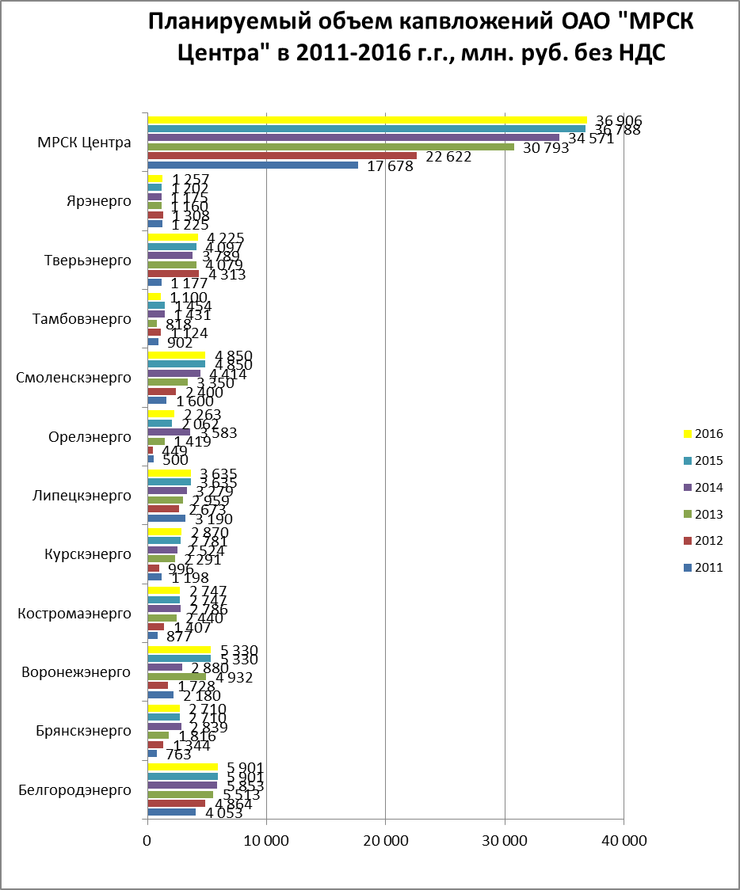

The ьфшт sources of financing of the investment program for 2011-2016 are:
- Depreciation
- New connection fee
- Use of bank credits for realisation of capital investments
- Profit of the fiscal year for use in the investment program
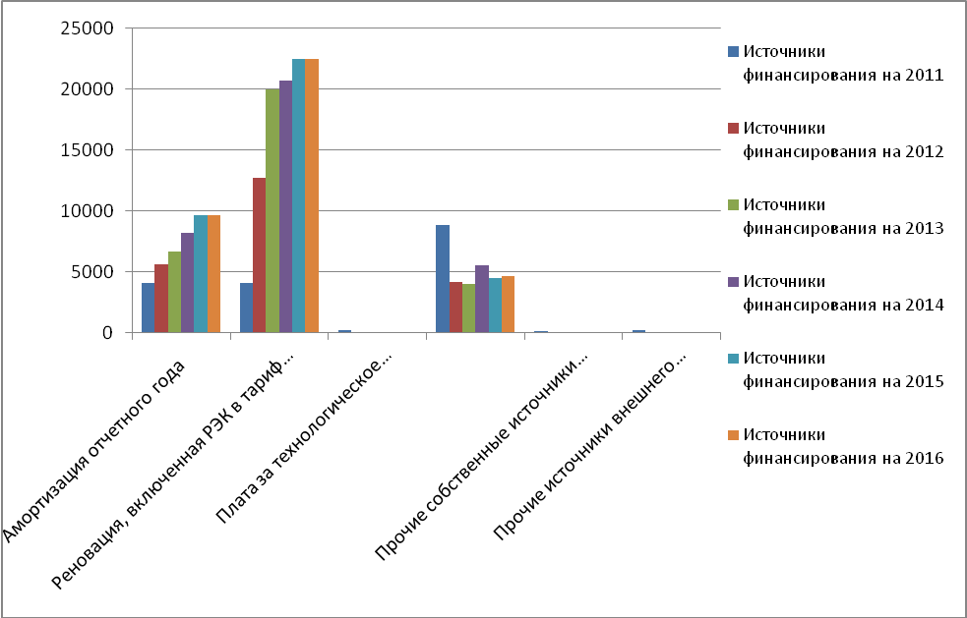
10 largest investment projects in 2010 with their key parametres
Division | The project name | Investments (plan) in million rbl. | Investments (actual) in million rbl. | Actual/Planned in % | Commissioning of capacities (conditionalunit)
Belgorodenergo | Construction of 110/10kV SS "Krapivenskaya" with overhangs | 198, 507 | 201,382 | 101 % | 32 MVA
Belgorodenergo | AMI for the retail market | 313,7 | 270 | 86 % | 30376 pieces
Bryanskenergo | Reconstruction of 110/35/6kV SS "Pochep" to connect a plant on destruction of chemical weapons | 15,299 | 483,208 | 3158 %
Voronezhenergo | Reconstruction 35/6kV SS #10 with transfer to 110 kV voltage class | 101,868 | 108,007 | 106 % | 126 MVA
Kostromaenergo | Reconstruction of 35/6 kV SS "Vostochnaya-1" with transfer to 110 kV voltage class | 67,465 | 62,500 | 93 %
Lipetskenergo | Construction of 110kV SS "Manezhnaya" | 35,888 | 53,404 | 149 % | 40 MVA
Kurskenergo | Reconstruction and construction of OL-110 kV, indoor switchgear with 110kV SF6 insulated switchgear at SS-110/10kV "Boiler-house" to deliver power from KSZR TGK-4 | 447,085 | 385,877 | 86 %
Orelenergo | Reconstruction of 110kV SS "Zapadnaya" | 183,956 | 232,629 | 126 % | 63 MVA
Kurskenergo | Construction of 110/10 kV SS "Rodniki" | 133,304 | 133,123 | 100 % | 50 MVA
Yarenergo | Construction of 110/6/6 kV SS "Kotorosl" | 177,256 | 178,949 | 101 % | 50 MVA

