DAILY
MARKET REVIEW
2014
| 24 January, Friday

REVIEW OF STOCK MARKETS  IDGC OF CENTRE |  |  | World indexes Value Change  for the day fr 31.12.13  MICEX 1 496,90 -0,12% -0,48%  S&P 500 1 828,46 -0,89% -1,08%  FTSE 100 6 773,28 -0,78% 0,36%  DAX 9 631,04 -0,92% 0,83%  DJStoxx 600 332,69 -1,00% 1,35%  STOXX Utilities 283,17 -0,18% 1,74%  Nikkei 15 695,89 -0,79% -3,65%  Sensex 21 373,66 0,17% 0,96%  CSI300 2 231,89 -0,53% -4,21%  Bovespa 48 320,64 -1,99% -6,19%  Source: Bloomberg, Company calculations  Currency rates Value Change  F for the day fr 31.12.13  Euro/USD 1,37 0,92% -0,83%  USD/RUB 33,87 0,16% 3,48%  Euro/RUB 45,91 0,19% 2,10%  Source: Bloomberg, Company calculations  Raw Value Change  for the day fr 31.12.13  Gold, USD/oz 1 264,13 2,18% 5,20%  Brent*, USD/bbl 107,58 -0,64% -2,67%  * - March futures  Source: Bloomberg, Company calculations  Shares of IDGC of Centre Value  Last transaction, RUB 0,2142  Capitalisation**, billion RUB 9,04  Capitalisation**, million USD 267,00  Source: Central Bank of Russia, Company calculations  ** - at the price of last transaction at MICEX  Russian indexes Change  for the day from 31.12.13  MICEX-Power Index 1,40% 3,55%  Shares of IDGC of Centre** 2,05% -2,01%  Source: MICEX, Company calculations  Grid companies Change**  for the day fr 31.12.13  JSC Russian Grids 1,12% 4,50%  FGC UES 0,35% 2,51%  IDGC of Volga -2,81% 1,84%  MOESK 0,61% -4,27%  IDGC of Northern Caucasus 1,00% -1,55%  IDGC of Centre and Volga Reg 0,23% 3,68%  IDGC of North-West 0,00% -0,11%  IDGC of Urals 0,30% 0,34%  IDGC of Siberia -5,07% -7,09%  IDGC of South -1,98% -6,03%  Lenenergo 0,04% 22,33%  Source: MICEX, Company calculations  ** - at the price of last transaction at MICEX  IDGC of Centre  127018, Russia, Moscow,  2nd Yamskaya, 4  +7 (495) 747 92 92  http://mrsk-1.com/en/investors/  IR Division  +7 (495) 747 92 92, ext. 33-34  ir@mrsk-1.ru  Tickers  Moscow Exchange MRKC  Bloomberg MRKC RX  Reuters MRKC.MM
Before the opening of trading some moderately negative external background formed on the Russian market. Major U.S. indices for the third consecutive session show mixed trends – on Wednesday S&P500 added 0.1%, DJIA lost 0.2%. In the absence of meaningful statistics quarterly statements remain the main driver for the market, in particular, the DJIA reduction was due to more than 3% decline in "heavy" index shares of IBM – investors were disappointed with continued seven consecutive quarters revenue reduction. Loss of major APR stock indices on an average exceeded half a percent, the composite MSCI Asia Pacific index decreased by one percent, and S & P500 futures – by 0.3%. Investors' pessimism was due to weak statistics from China, where, according to preliminary HSBC data, the index of manufacturing activity in January fell below the key level of 50 points for the first time since July 2013. March Brent traded near $108 a barrel – half a dollar higher than our closing on Wednesday.
Most of the trading session the growth rate of the MICEX Index was over half a percent. Our market was supported with rising oil prices and good data on business activity in the Eurozone: the region composite PMI rose to its highest level since June 2011, the industrial PMI of Europe's largest economy – Germany – to the maximum since May 2011. However, the Russian market growth was restrained with uncertain mood of European investors, ignoring their own good statistics on the background of negative dynamics of futures for U.S. indices. At the end of the day the decline of U.S. futures and European indices accelerated despite released better than expected data on applications for unemployment benefits in the U.S. That change put some significant pressure on the Russian market – the MICEX Index, having lost all day achievements, closed below zero.
Following the results of the day the MICEX Index fell by 0.12% to close trading at 1,496.90 points. Dynamics of the MicexPWR Sector Index outperformed the market. The main contribution to the resulting increase in the index, more than 50%, was made by shares of Inter RAO, which had resumed their growth after three days of consolidation and today added 6.8%. On Western exchanges the European DJStoxx 600 Index fell by 1.00%, and the American S&P 500 Index decreased by 0.89%.
ELECTRIC POWER INDUSTRY NEWS
Russia plans to abandon the power market in the long term
The Russian Ministry of Energy offers in the future to correct the model of the wholesale electric energy and power market while considering the possibility of transition to an electric energy market exclusively, the Ministry said in a draft energy strategy of Russia until 2035.
To read full text: http://www.bigpowernews.ru/news/document54291.phtml
BigpowerNews published a draft of the updated energy strategy of Russia until 2035
To read full text: http://www.bigpowernews.ru/news/document54286.phtml
COMPANY NEWS
IDGC of Centre in 2013 exceeded the annual plan for clearing ROWs of overhead lines by 3%
IDGC of Centre following the results of 2013 exceeded the annual program of clearing ROWs of overhead power lines (conductors). Specialists of the company in excess of the annual plan cleared 320 hectares of ROWs, its performance was at 102.9%.
To read full text: http://www.mrsk-1.ru/ru/press/news/company/?id_4=89067
DYNAMICS OF KEY INDEXES AND SHARES OF THE COMPANY
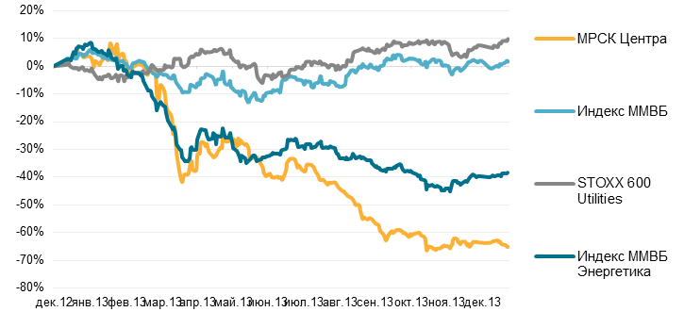
IDGC of Centre

Dec-12 Jan-13 Feb-13 Mar-13 Apr-13 May-13 June-13 July-13 Aug-13 Sep-13 Oct-13 Nov-13 Dec-13
MICEX POWER
MICEX Index
Follow us on Twitter | Like us on Facebook | Watch us on SlideShare | Join us on Euroland | Visit our Website

